Task 1

Design and implement a network service that reliably handles concurrent client connections while ensuring graceful termination in response to external signals (e.g., SIGTERM, SIGINT). The service must maintain data consistency and avoid resource leaks throughout its lifecycle.

Server code:

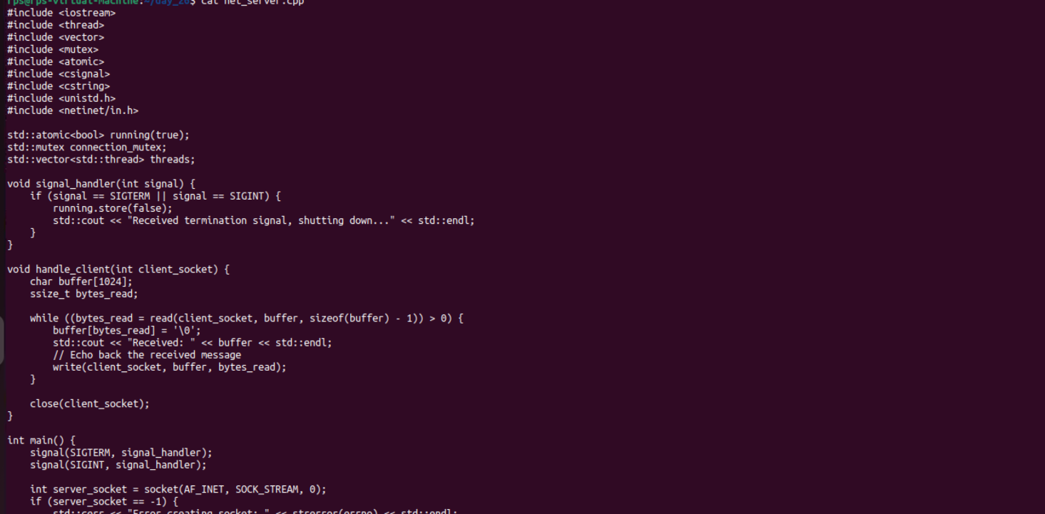

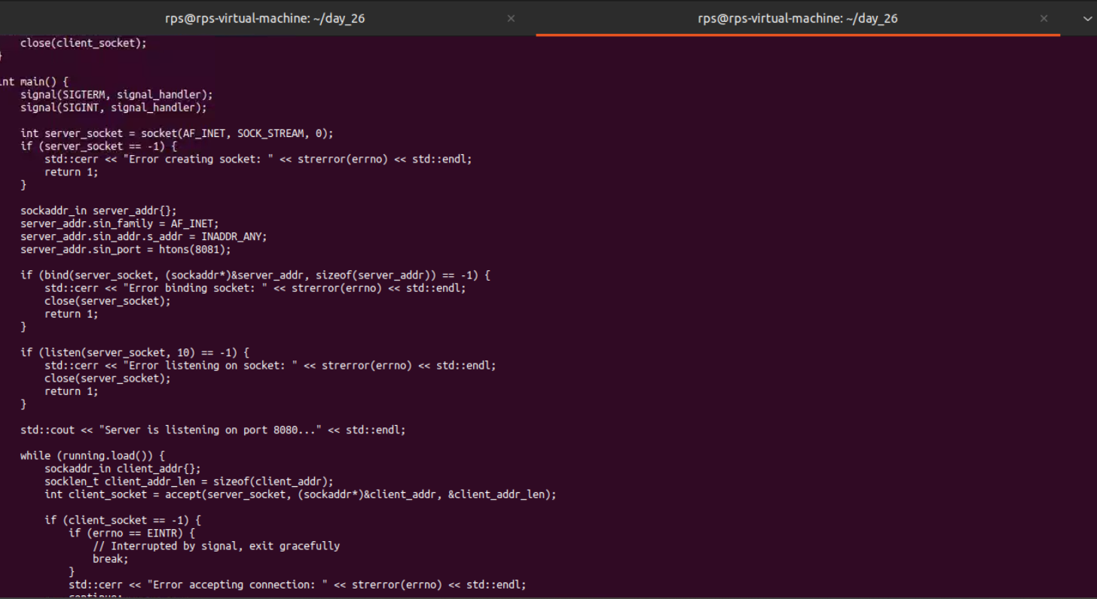

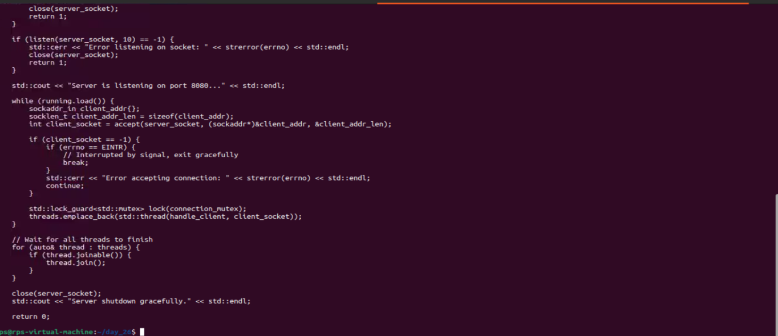

Client code: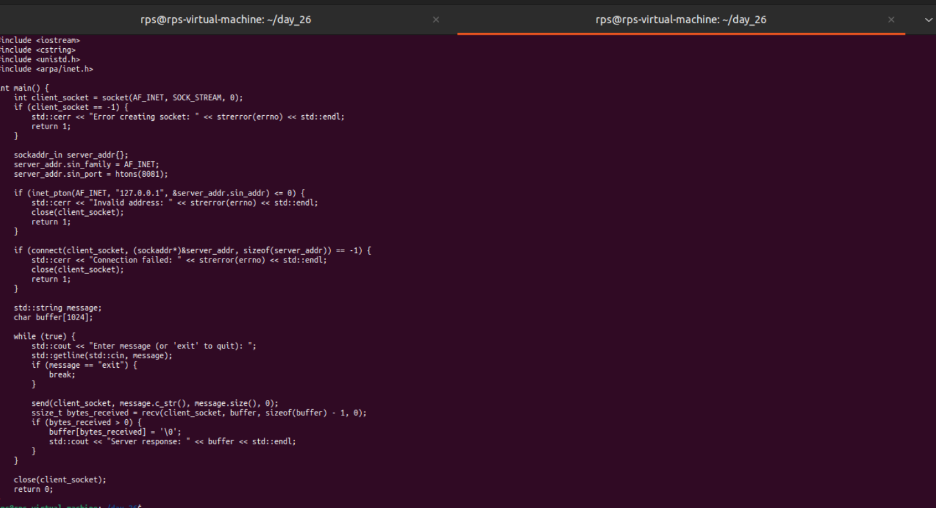

Output:

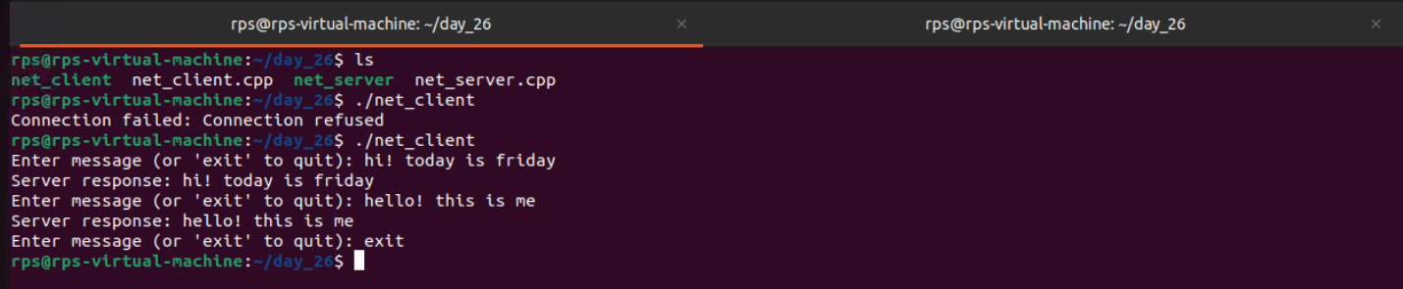

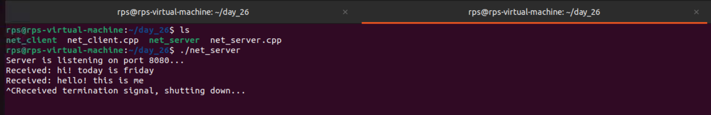

Client and Server chat from other devices

Server Code :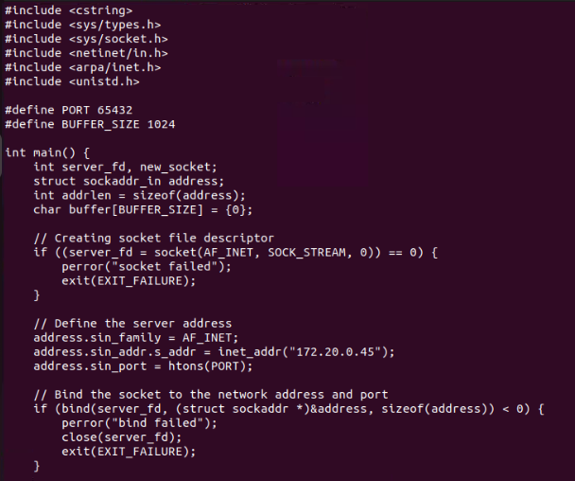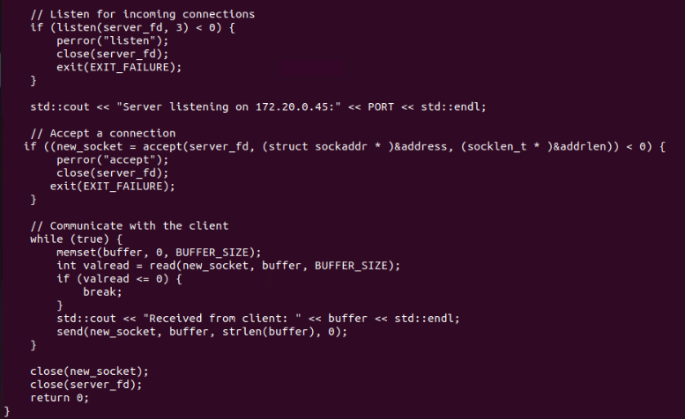

Output Server :

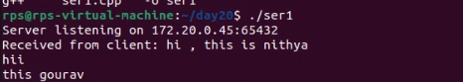

Client code :

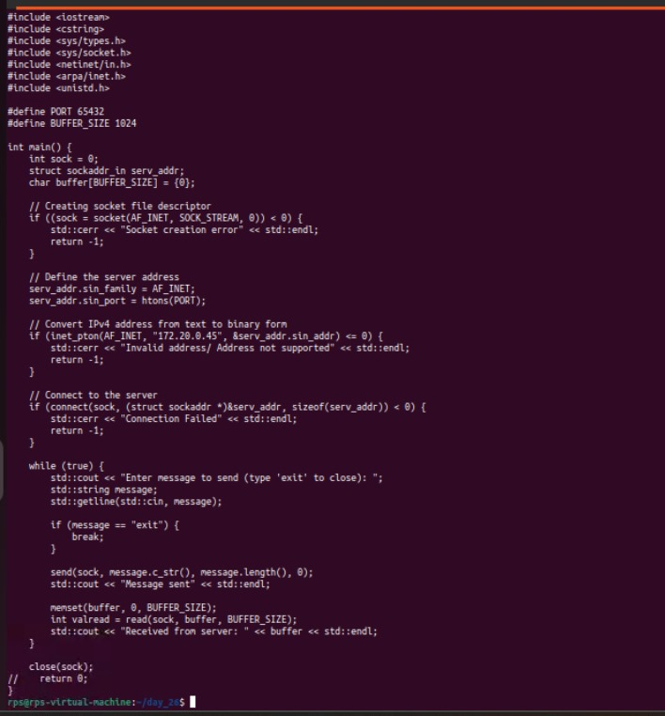

Output :

